SEC Form 4

FORM 4

Check this box if no longer subject to Section 16. Form 4 or Form 5 obligations may continue. See Instruction 1(b).

UNITED STATES SECURITIES AND EXCHANGE COMMISSION
Washington, D.C. 20549
 |  | OMB APPROVAL
STATEMENT OF CHANGES IN BENEFICIAL OWNERSHIP
 |  | OMB Number: | 3235-0287
 |  | Estimated average burden
Filed pursuant to Section 16(a) of the Securities Exchange Act of 1934 |  | hours per response: | 0.5
or Section 30(h) of the Investment Company Act of 1940
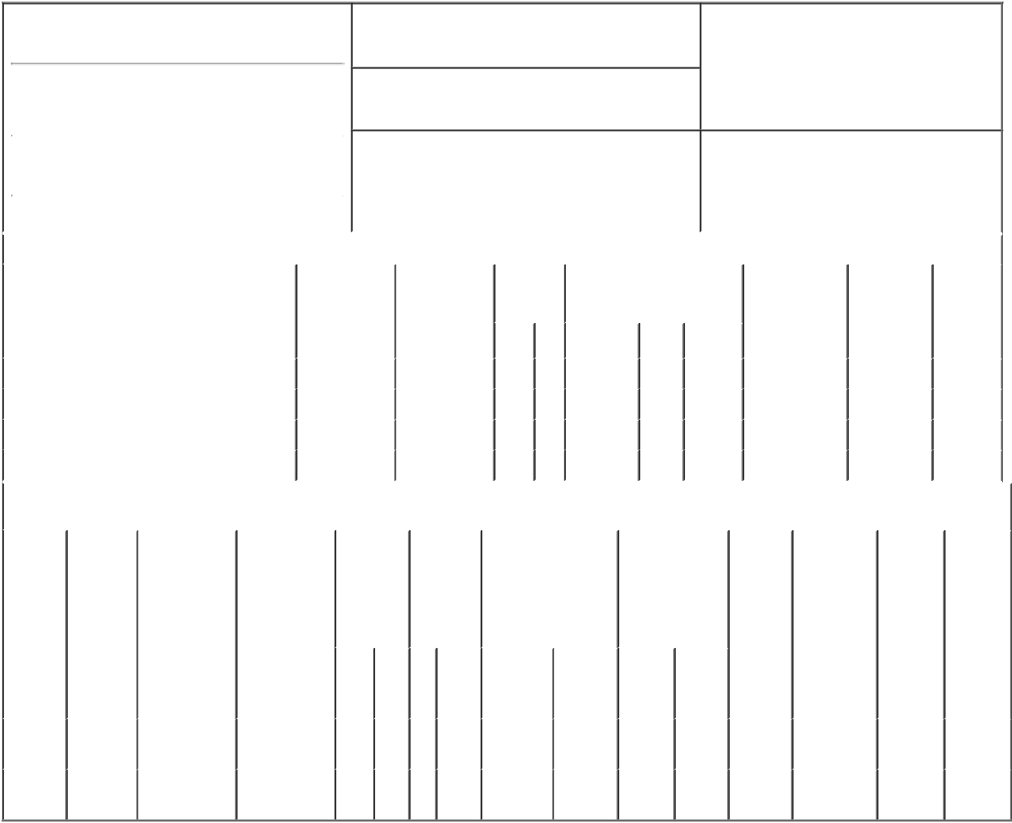

1. Name and Address of Reporting Person*
Rowe Robert Scott

(Last) (First) (Middle)

5215 NORTH O'CONNOR BLVD SUITE 2300

2. Issuer Name and Ticker or Trading Symbol

FLOWSERVE CORP [ FLS ]

3. Date of Earliest Transaction (Month/Day/Year)

02/28/2020

- Relationship of Reporting Person(s) to Issuer (Check all applicable)

X | Director | 10% Owner
X | Officer (give title | Other (specify
 | below) | below)

President & CEO

 |  |  |  |  |  |  | 4. If Amendment, Date of Original Filed (Month/Day/Year) |  |  |  |  |  | 6. Individual or Joint/Group Filing (Check Applicable
 | (Street)
 |  |  |  |  |  |  |  |  |  |  |  |  | Line)
 |  | IRVING | TX |  | 75039 |  |  |  |  |  |  |  | X Form filed by One Reporting Person
 |  |  |  |  |  |  |  |  |  |  |  |  |  |  |  | Form filed by More than One Reporting
 |  | (City) | (State) |  | (Zip) |  |  |  |  |  |  |  |  |  |  | Person
 |  |  |  | Table I - Non-Derivative Securities Acquired, Disposed of, or Beneficially Owned
 | 1. Title of Security (Instr. 3) |  |  |  | 2. Transaction |  |  | 2A. Deemed | 3. |  | 4. Securities Acquired (A) or |  |  |  |  | 5. Amount of |  | 6. Ownership |  | 7. Nature
 |  |  |  |  | Date |  |  | Execution Date, |  | Transaction Disposed Of (D) (Instr. 3, 4 and |  |  |  |  |  | Securities |  | Form: Direct |  | of Indirect
 |  |  |  |  | (Month/Day/Year) |  |  | if any |  | Code (Instr. | 5) |  |  |  |  | Beneficially |  | (D) or Indirect |  | Beneficial
 |  |  |  |  |  |  |  | (Month/Day/Year) 8) |  |  |  |  |  |  |  | Owned Following |  | (I) (Instr. 4) |  | Ownership
 |  |  |  |  |  |  |  |  |  |  |  |  |  |  |  | Reported |  |  |  | (Instr. 4)
 |  |  |  |  |  |  |  |  |  | Code V | Amount | (A) or | Price |  |  | Transaction(s)
 |  |  |  |  |  |  |  |  |  |  |  | (D) |  |  |  | (Instr. 3 and 4)
 | Common Stock |  |  |  | 02/28/2020 |  |  |  |  | M | 22,242 | A | $0 |  |  | 85,578 |  |  | D
 | Common Stock |  |  |  | 02/28/2020 |  |  |  |  | F | 5,411 | D | $40.19 |  |  | 80,167 |  |  | D
 | Common Stock |  |  |  | 03/01/2020 |  |  |  |  | M | 22,732 | A | $0 |  |  | 102,899 |  |  | D
 | Common Stock |  |  |  | 03/01/2020 |  |  |  |  | F | 8,551 | D | $40.19 |  |  | 94,348 |  |  | D
 |  |  |  |  | Table II - Derivative Securities Acquired, Disposed of, or Beneficially Owned
 |  |  |  |  | (e.g., puts, calls, warrants, options, convertible securities)
 | 1. Title of |  | 2. | 3. Transaction | 3A. Deemed | 4. |  | 5. Number | 6. Date Exercisable and |  |  | 7. Title and Amount |  |  | 8. Price of |  | 9. Number of |  | 10. | 11. Nature
 | Derivative |  | Conversion | Date | Execution Date, | Transaction |  | of | Expiration Date |  |  | of Securities |  |  | Derivative |  | derivative |  | Ownership | of Indirect
 | Security |  | or Exercise | (Month/Day/Year) | if any | Code (Instr. |  | Derivative | (Month/Day/Year) |  |  | Underlying |  |  | Security |  | Securities |  | Form: | Beneficial
 | (Instr. 3) |  | Price of |  | (Month/Day/Year) | 8) |  | Securities |  |  |  | Derivative Security |  |  | (Instr. 5) |  | Beneficially |  | Direct (D) | Ownership
 |  |  | Derivative |  |  |  |  | Acquired |  |  |  | (Instr. 3 and 4) |  |  |  |  | Owned |  | or Indirect | (Instr. 4)
 |  |  | Security |  |  |  |  | (A) or |  |  |  |  |  |  |  |  | Following |  | (I) (Instr. 4)
 |  |  |  |  |  |  |  | Disposed |  |  |  |  |  |  |  |  | Reported
 |  |  |  |  |  |  |  | of (D) (Instr. |  |  |  |  |  |  |  |  | Transaction(s)
 |  |  |  |  |  |  |  | 3, 4 and 5) |  |  |  |  |  |  |  |  | (Instr. 4)
 |  |  |  |  |  |  |  |  |  |  |  |  | Amount
 |  |  |  |  |  |  |  |  |  |  |  |  | or
 |  |  |  |  |  |  |  |  |  |  |  |  | Number
 |  |  |  |  |  |  |  |  | Date |  | Expiration |  | of
 |  |  |  |  |  | Code V |  | (A) (D) | Exercisable |  | Date | Title | Shares
 | Restricted |  | (1) |  |  |  |  |  | (1) |  | (1) | Common | 21,893
 | Stock |  |  | 02/28/2020 |  |  | M | 21,893 |  |  |  |  |  |  |  | $0 | 167,000 |  | D
 | Units |  |  |  |  |  |  |  |  |  |  | Stock
 | Restricted |  | (1) |  |  |  |  |  | (1) |  | (1) | Common | 21,997
 | Stock |  |  | 03/01/2020 |  |  | M | 21,997 |  |  |  |  |  |  |  | $0 | 145,003 |  | D
 | Units |  |  |  |  |  |  |  |  |  |  | Stock

Explanation of Responses:

- Each restricted stock unit represents the right to receive, at settlement, one share of common stock (plus dividends accrued on the underlying shares) and are granted to the reporting person pursuant to the issuer's long-term incentive compensation plan for employees. The shares vest ratably over a three-year period on each annual anniversary of the grant.

Remarks:
/s/ Akshar C. Patel, attorney-in- _{03/02/2020}
fact

** Signature of Reporting Person Date

Reminder: Report on a separate line for each class of securities beneficially owned directly or indirectly.

* If the form is filed by more than one reporting person, see Instruction 4 (b)(v).

- Intentional misstatements or omissions of facts constitute Federal Criminal Violations See 18 U.S.C. 1001 and 15 U.S.C. 78ff(a). Note: File three copies of this Form, one of which must be manually signed. If space is insufficient, see Instruction 6 for procedure.
Persons who respond to the collection of information contained in this form are not required to respond unless the form displays a currently valid OMB Number.

