SEC Form 4

FORM 4

Check this box if no longer subject to Section 16. Form 4 or Form 5 obligations may continue. See Instruction 1(b).

UNITED STATES SECURITIES AND EXCHANGE COMMISSION
Washington, D.C. 20549
 |  | OMB APPROVAL
STATEMENT OF CHANGES IN BENEFICIAL OWNERSHIP
 |  | OMB Number: | 3235-0287
 |  | Estimated average burden
Filed pursuant to Section 16(a) of the Securities Exchange Act of 1934 |  | hours per response: | 0.5
or Section 30(h) of the Investment Company Act of 1940
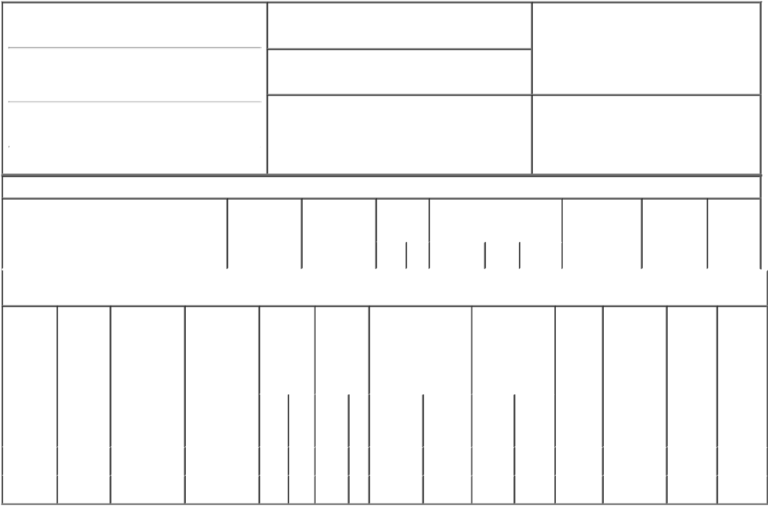

1. Name and Address of Reporting Person*
Gillespie Keith E.

(Last) (First) (Middle)

5215 NORTH O'CONNOR BLVD #2300

2. Issuer Name and Ticker or Trading Symbol

FLOWSERVE CORP [ FLS ]

3. Date of Earliest Transaction (Month/Day/Year)

02/28/2018

- Relationship of Reporting Person(s) to Issuer (Check all applicable)

 | Director | 10% Owner
X | Officer (give title | Other (specify
 | below) | below)

SVP, Chief Sales Officer

(Street)
 | IRVING | TX | 75039
 | (City) | (State) | (Zip)

4. If Amendment, Date of Original Filed (Month/Day/Year) 6. Individual or Joint/Group Filing (Check Applicable
Line)
X Form filed by One Reporting Person

Form filed by More than One Reporting
Person

Table I - Non-Derivative Securities Acquired, Disposed of, or Beneficially Owned

 | 1. Title of Security (Instr. 3) | 2. Transaction | 2A. Deemed | 3. | 4. Securities Acquired (A) or |  |  | 5. Amount of | 6. Ownership | 7. Nature of
 |  | Date | Execution Date, | Transaction | Disposed Of (D) (Instr. 3, 4 and |  |  | Securities | Form: Direct | Indirect
 |  | (Month/Day/Year) | if any | Code (Instr. | 5) |  |  | Beneficially | (D) or Indirect | Beneficial
 |  |  | (Month/Day/Year) | 8) |  |  |  | Owned Following | (I) (Instr. 4) | Ownership
 |  |  |  |  |  |  |  | Reported |  | (Instr. 4)
 |  |  |  | Code V | Amount | (A) or | Price | Transaction(s)
 |  |  |  |  |  | (D) |  | (Instr. 3 and 4)

Table II - Derivative Securities Acquired, Disposed of, or Beneficially Owned

(e.g., puts, calls, warrants, options, convertible securities)

1. Title of | 2. | 3. Transaction | 3A. Deemed | 4. | 5. Number |  | 6. Date Exercisable and |  | 7. Title and Amount |  | 8. Price of | 9. Number of | 10. | 11. Nature
Derivative | Conversion | Date | Execution Date, | Transaction | of |  | Expiration Date |  | of Securities |  | Derivative | derivative | Ownership | of Indirect
Security | or Exercise | (Month/Day/Year) | if any | Code (Instr. | Derivative |  | (Month/Day/Year) |  | Underlying |  | Security | Securities | Form: | Beneficial
(Instr. 3) | Price of |  | (Month/Day/Year) | 8) | Securities |  |  |  | Derivative Security |  | (Instr. 5) | Beneficially | Direct (D) | Ownership
 | Derivative |  |  |  | Acquired |  |  |  | (Instr. 3 and 4) |  |  | Owned | or Indirect | (Instr. 4)
 | Security |  |  |  | (A) or |  |  |  |  |  |  | Following | (I) (Instr. 4)
 |  |  |  |  | Disposed |  |  |  |  |  |  | Reported
 |  |  |  |  | of (D) (Instr. |  |  |  |  |  |  | Transaction(s)
 |  |  |  |  | 3, 4 and 5) |  |  |  |  |  |  | (Instr. 4)
 |  |  |  |  |  |  |  |  |  | Amount
 |  |  |  |  |  |  |  |  |  | or
 |  |  |  |  |  |  |  |  |  | Number
 |  |  |  |  |  |  | Date | Expiration |  | of
 |  |  |  | Code V | (A) | (D) | Exercisable | Date | Title | Shares
Restricted | (1) | 02/28/2018 |  | A | 11,640 |  | (1) | (1) | Common | 11,640 | $0 | 22,017 | D
Stock Units |  |  |  |  |  |  |  |  | Stock
Performance | (2) | 02/28/2018 |  | A | 11,640 |  | (2) | (2) | Common | 11,640 | $0 | 32,960 | D
Rights |  |  |  |  |  |  |  |  | Stock

Explanation of Responses:

- Each restricted stock unit represents the right to receive, at settlement, one share of common stock (plus dividends accrued on the underlying shares) and are granted to the reporting person pursuant to the issuer's long-term incentive compensation plan for employees. The shares vest ratably over a three-year period on each annual anniversary of the grant.

- Each performance right represents a contingent right to receive one share of the issuer's common stock at vesting. The performance rights vest at a rate between 0% and 200% and are based on two factors during a three-year performance cycle beginning on January 1, 2018 and ending on December 31, 2020 which are: 1) the issuer's relative total share holder return ("TSR") in comparison to the TSR averages of a predetermined peer group over the performance cycle; and 2) the issuer's return on invested capital measured against the issuer's performance relative to its weighted average cost of capital and relative to a predetermined peer group over the performance cycle. The performance rights may be settled, at the issuer's discretion, in cash or shares of common stock.

Remarks:

/s/ Carey A. O'Connor, |  |  | 03/01/2018
attorney-in-fact
** Signature of Reporting Person |  |  | Date

Reminder: Report on a separate line for each class of securities beneficially owned directly or indirectly.

* If the form is filed by more than one reporting person, see Instruction 4 (b)(v).

- Intentional misstatements or omissions of facts constitute Federal Criminal Violations See 18 U.S.C. 1001 and 15 U.S.C. 78ff(a). Note: File three copies of this Form, one of which must be manually signed. If space is insufficient, see Instruction 6 for procedure.
Persons who respond to the collection of information contained in this form are not required to respond unless the form displays a currently valid OMB Number.

