SEC Form 4

FORM 4

Check this box if no longer subject to Section 16. Form 4 or Form 5 obligations may continue. See Instruction 1(b).

UNITED STATES SECURITIES AND EXCHANGE COMMISSION
Washington, D.C. 20549
 |  | OMB APPROVAL
STATEMENT OF CHANGES IN BENEFICIAL OWNERSHIP
 |  | OMB Number: | 3235-0287
 |  | Estimated average burden
Filed pursuant to Section 16(a) of the Securities Exchange Act of 1934 |  | hours per response: | 0.5
or Section 30(h) of the Investment Company Act of 1940

 | 1. Name and Address of Reporting Person* |  |  |  |  |  |  | 2. Issuer Name and Ticker or Trading Symbol |  |  |  |  |  |  |  |  | 5. Relationship of Reporting Person(s) to Issuer
 |  | Chand Sujeet |  |  |  |  |  | FLOWSERVE CORP [ FLS ] |  |  |  |  |  |  |  |  | (Check all applicable)
 |  |  |  |  |  |  |  |  |  |  |  |  |  |  |  |  | X Director |  |  |  |  |  | 10% Owner
 |  |  |  |  |  |  |  |  |  |  |  |  |  |  |  |  |  |  |  | Officer (give title |  |  | Other (specify
 |  |  |  |  |  |  |  | 3. Date of Earliest Transaction (Month/Day/Year)
 |  | (Last) | (First) |  | (Middle) |  |  |  |  |  |  |  |  |  |  |  |  |  |  | below) |  |  | below)
 |  |  |  |  |  |  | 05/22/2020
 |  | 5215 N. O'CONNOR BLVD.
 |  | SUITE 2300
 |  |  |  |  |  |  |  | 4. If Amendment, Date of Original Filed (Month/Day/Year) |  |  |  |  |  |  |  |  | 6. Individual or Joint/Group Filing (Check Applicable
 |  |  |  |  |  |  |  |  |  |  |  |  |  |  |  |  | Line)
 | (Street) |  |  |  |  |  |  |  |  |  |  |  |  |  |  |  | X Form filed by One Reporting Person
 |  | IRVING | TX |  | 75039 |  |  |  |  |  |  |  |  |  |  |  |  |  |  | Form filed by More than One Reporting
 |  |  |  |  |  |  |  |  |  |  |  |  |  |  |  |  |  |  |  | Person
 |  | (City) | (State) |  | (Zip)
 |  |  |  | Table I - Non-Derivative Securities Acquired, Disposed of, or Beneficially Owned
 | 1. Title of Security (Instr. 3) |  |  |  | 2. Transaction |  |  |  | 2A. Deemed |  | 3. |  |  | 4. Securities Acquired (A) or |  |  |  |  |  | 5. Amount of |  | 6. Ownership |  | 7. Nature
 |  |  |  |  | Date |  |  |  | Execution Date, |  |  | Transaction |  | Disposed Of (D) (Instr. 3, 4 and |  |  |  |  |  | Securities |  | Form: Direct |  | of Indirect
 |  |  |  |  | (Month/Day/Year) |  |  |  | if any |  |  | Code (Instr. |  | 5) |  |  |  |  |  | Beneficially |  | (D) or Indirect |  | Beneficial
 |  |  |  |  |  |  |  |  | (Month/Day/Year) 8) |  |  |  |  |  |  |  |  |  |  | Owned Following |  | (I) (Instr. 4) |  | Ownership
 |  |  |  |  |  |  |  |  |  |  |  |  |  |  |  |  |  |  |  | Reported |  |  |  | (Instr. 4)
 |  |  |  |  |  |  |  |  |  |  |  | Code V |  | Amount | (A) or | Price |  |  |  | Transaction(s)
 |  |  |  |  |  |  |  |  |  |  |  |  |  |  | (D) |  |  |  |  | (Instr. 3 and 4)
 |  |  |  | Table II - Derivative Securities Acquired, Disposed of, or Beneficially Owned
 |  |  |  |  | (e.g., puts, calls, warrants, options, convertible securities)
 | 1. Title of |  | 2. | 3. Transaction | 3A. Deemed |  | 4. |  | 5. Number |  | 6. Date Exercisable and |  |  |  | 7. Title and |  |  |  | 8. Price of |  | 9. Number of |  | 10. | 11. Nature
 | Derivative |  | Conversion | Date | Execution Date, |  | Transaction of |  |  |  | Expiration Date |  |  |  | Amount of |  |  |  | Derivative |  | derivative |  | Ownership | of Indirect
 | Security |  | or Exercise | (Month/Day/Year) | if any |  | Code (Instr. |  | Derivative |  | (Month/Day/Year) |  |  |  | Securities |  |  |  | Security |  | Securities |  | Form: | Beneficial
 | (Instr. 3) |  | Price of |  | (Month/Day/Year) |  | 8) |  | Securities |  |  |  |  |  | Underlying |  |  |  | (Instr. 5) |  | Beneficially |  | Direct (D) | Ownership
 |  |  | Derivative |  |  |  |  |  | Acquired |  |  |  |  |  | Derivative Security |  |  |  |  |  | Owned |  | or Indirect | (Instr. 4)
 |  |  | Security |  |  |  |  |  | (A) or |  |  |  |  |  | (Instr. 3 and 4) |  |  |  |  |  | Following |  | (I) (Instr. 4)
 |  |  |  |  |  |  |  |  | Disposed |  |  |  |  |  |  |  |  |  |  |  | Reported
 |  |  |  |  |  |  |  |  | of (D) |  |  |  |  |  |  |  |  |  |  |  | Transaction(s)
 |  |  |  |  |  |  |  |  | (Instr. 3, 4 |  |  |  |  |  |  |  |  |  |  |  | (Instr. 4)
 |  |  |  |  |  |  |  |  | and 5)
 |  |  |  |  |  |  |  |  |  |  |  |  |  |  |  | Amount
 |  |  |  |  |  |  |  |  |  |  |  |  |  |  |  | or
 |  |  |  |  |  |  |  |  |  |  |  |  |  |  |  | Number
 |  |  |  |  |  |  |  |  |  |  | Date |  | Expiration |  |  | of
 |  |  |  |  |  |  | Code V |  | (A) | (D) | Exercisable |  | Date |  | Title | Shares
 | Phantom |  | (1) | 05/22/2020 |  |  |  | A | 2,628 |  | (2) |  |  | (2) | Common | 2,628 |  |  | $25.2 |  | 4,559 |  | D
 | Stock |  |  |  |  |  |  |  |  |  |  |  |  |  | Stock
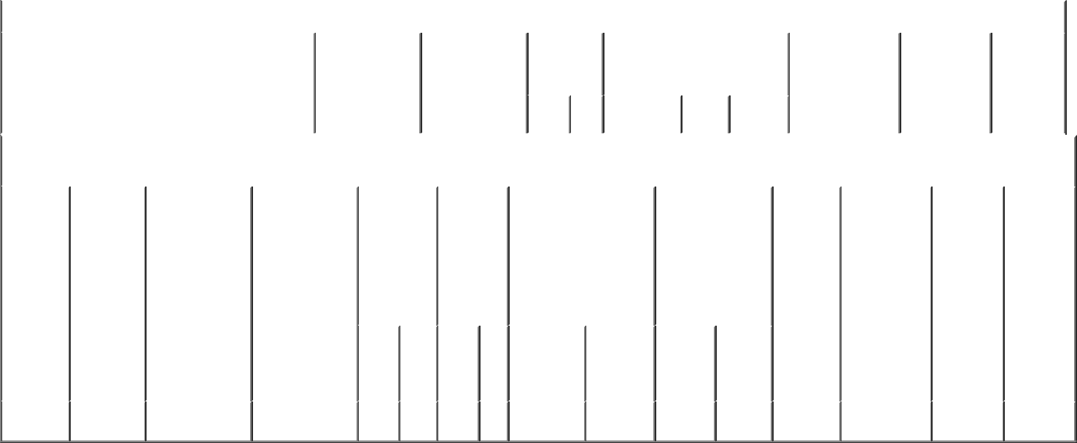

Explanation of Responses:

- Each share of phantom stock is the economic equivalent of one share of common stock, and represents director compensation deferred in the form of common stock pursuant to the issuer's deferred compensation plan.

- The shares of phantom stock become payable in the form of common stock upon the reporting person's termination of service as a member of the issuer's board of directors.

Remarks:

/s/ Akshar C. Patel, attorney- |  |  | 05/26/2020
in-fact
** Signature of Reporting Person |  |  | Date

Reminder: Report on a separate line for each class of securities beneficially owned directly or indirectly.

* If the form is filed by more than one reporting person, see Instruction 4 (b)(v).

- Intentional misstatements or omissions of facts constitute Federal Criminal Violations See 18 U.S.C. 1001 and 15 U.S.C. 78ff(a). Note: File three copies of this Form, one of which must be manually signed. If space is insufficient, see Instruction 6 for procedure.
Persons who respond to the collection of information contained in this form are not required to respond unless the form displays a currently valid OMB Number.

