SEC Form 4

FORM 4

Check this box if no longer subject to Section 16. Form 4 or Form 5 obligations may continue. See Instruction 1(b).

UNITED STATES SECURITIES AND EXCHANGE COMMISSION
Washington, D.C. 20549
 |  | OMB APPROVAL
STATEMENT OF CHANGES IN BENEFICIAL OWNERSHIP
 |  | OMB Number: | 3235-0287
 |  | Estimated average burden
Filed pursuant to Section 16(a) of the Securities Exchange Act of 1934 |  | hours per response: | 0.5
or Section 30(h) of the Investment Company Act of 1940
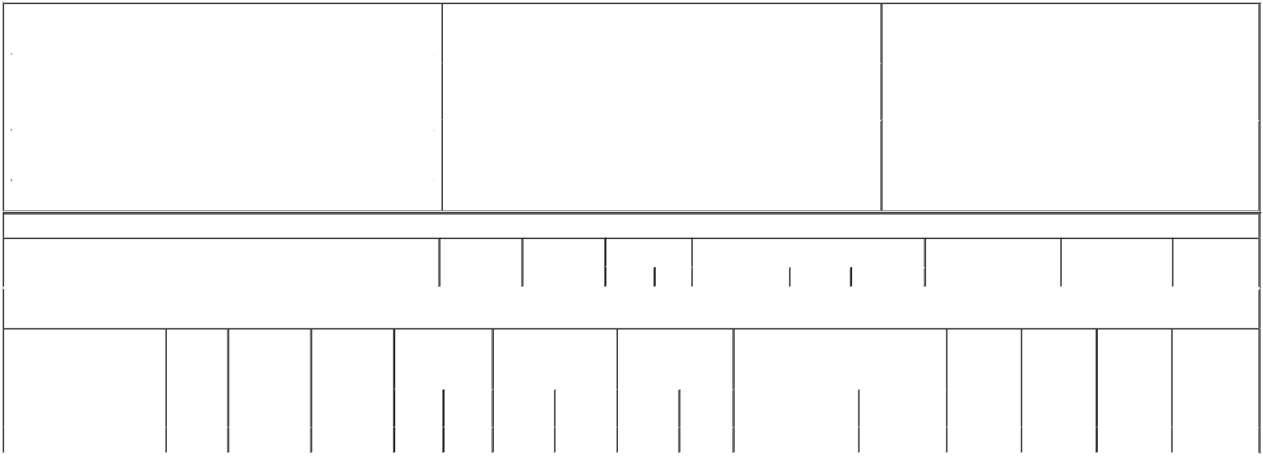

1. Name and Address of Reporting Person* |  |  |  |  |  |  | 2. Issuer Name and Ticker or Trading Symbol |  | 5. Relationship of Reporting Person(s) to Issuer
 | GARRISON JOHN L JR |  |  |  |  |  | FLOWSERVE CORP [ FLS ] |  | (Check all applicable)
 |  |  |  |  |  |  |  |  | X | Director | 10% Owner
 |  |  |  |  |  |  |  |  |  | Officer (give title below) | Other (specify below)
 | (Last) | (First) |  | (Middle)
 |  |  |  |  |  |  | 3. Date of Earliest Transaction (Month/Day/Year)
 | 5215 N O CONNOR BLVD |  |  |  | 05/13/2019
# 2300
 |  |  |  |  |  |  | 4. If Amendment, Date of Original Filed (Month/Day/Year) |  | 6. Individual or Joint/Group Filing (Check Applicable Line)
(Street) |  |  |  |  |  |  |  |  | X | Form filed by One Reporting Person
 | IRVING | TX |  | 75039 |  |  |  |  |  | Form filed by More than One Reporting Person
 | (City) | (State) |  | (Zip)

Table I - Non-Derivative Securities Acquired, Disposed of, or Beneficially Owned

1. Title of Security (Instr. 3) | 2. Transaction | 2A. Deemed | 3. Transaction |  | 4. | Securities Acquired (A) or Disposed Of (D) (Instr. |  |  | 5. Amount of Securities | 6. Ownership Form: | 7. Nature of
 | Date | Execution Date, | Code (Instr. 8) |  | 3, | 4 and 5) |  |  | Beneficially Owned Following | Direct (D) or Indirect (I) | Indirect Beneficial
 | (Month/Day/Year) | if any |  |  |  |  |  |  | Reported Transaction(s) | (Instr. 4) | Ownership (Instr.
 |  | (Month/Day/Year) | Code | V | Amount |  | (A) or (D) | Price | (Instr. 3 and 4) |  | 4)

Table II - Derivative Securities Acquired, Disposed of, or Beneficially Owned

(e.g., puts, calls, warrants, options, convertible securities)

1. Title of Derivative Security (Instr. | 2. | 3. Transaction | 3A. Deemed | 4. Transaction Code |  | 5. Number of Derivative |  | 6. Date Exercisable and |  | 7. Title and Amount of Securities Underlying |  |  |  | 8. Price of |  | 9. Number of |  | 10. Ownership | 11. Nature of
3) | Conversion | Date | Execution Date, | (Instr. 8) |  | Securities Acquired (A) or |  | Expiration Date |  | Derivative Security (Instr. 3 and 4) |  |  |  | Derivative |  | derivative |  | Form: Direct | Indirect Beneficial
 | or Exercise | (Month/Day/Year) | if any |  |  | Disposed of (D) (Instr. 3, 4 |  | (Month/Day/Year) |  |  |  |  |  | Security (Instr. |  | Securities |  | (D) or Indirect | Ownership (Instr.
 | Price of |  | (Month/Day/Year) |  |  | and 5) |  |  |  |  |  |  |  | 5) |  | Beneficially |  | (I) (Instr. 4) | 4)
 | Derivative |  |  |  |  |  |  |  |  |  |  |  |  |  |  | Owned
 | Security |  |  |  |  |  |  |  |  |  |  |  |  |  |  | Following
 |  |  |  |  |  |  |  |  |  |  |  |  |  |  |  | Reported
 |  |  |  |  |  |  |  | Date | Expiration |  |  | Amount or |  |  |  | Transaction(s)
 |  |  |  | Code | V | (A) | (D) | Exercisable | Date | Title |  | Number of Shares |  |  |  | (Instr. 4)
Phantom Stock | (1) | 05/13/2019 |  | A |  | 604 |  | (2) | (2) |  | Common Stock | 604 |  | $47.62 |  | 1,273 |  | D
Explanation of Responses:
1. Each share of phantom stock is the economic equivalent of one share of common stock, and represents director compensation deferred in the form of common stock pursuant to the issuer's deferred compensation plan.
2. The shares of phantom stock become payable in the form of common stock upon the reporting person's termination of service as a member of the issuer's board of directors.
Remarks:
 |  |  |  |  |  |  |  |  |  |  | /s/ Akshar C. Patel, attorney-in-fact |  |  |  | 05/15/2019
 |  |  |  |  |  |  |  |  |  |  | ** Signature of Reporting Person |  |  |  | Date

Reminder: Report on a separate line for each class of securities beneficially owned directly or indirectly.

* If the form is filed by more than one reporting person, see Instruction 4 (b)(v).

- Intentional misstatements or omissions of facts constitute Federal Criminal Violations See 18 U.S.C. 1001 and 15 U.S.C. 78ff(a). Note: File three copies of this Form, one of which must be manually signed. If space is insufficient, see Instruction 6 for procedure.
Persons who respond to the collection of information contained in this form are not required to respond unless the form displays a currently valid OMB Number.

Section 16 Power of Attorney
LIMITED POWER OF ATTORNEY

The undersigned hereby constitutes and appoints each of R. Scott Rowe, Lanesha Minnix, Akshar C. Patel, Lee S. Eckert and Shakeeb U. Mir, signing singly, the unders

- execute for and on behalf of the undersigned, in the undersigned's capacity as an officer and/or director of Flowserve Corporation (the "Company"), Forms 3, 4 a

- do and perform any and all acts for and on behalf of the undersigned that may be necessary, desirable or appropriate to complete and execute any such Form 3, 4

- take any and all other action of any type whatsoever in connection with the foregoing that, in the opinion of such attorney-in-fact, may be of benefit to, in th The undersigned hereby grants to each such attorney-in-fact full power and authority to do and perform any and every act and thing whatsoever requisite, necessary o This Power of Attorney shall remain in full force and effect until the undersigned is no longer required to file Forms 3, 4 and 5 with respect to the undersigned's The undersigned is executing this Power of Attorney on the date set forth below.

/s/ John L. Garrison Jr.
Signature

John L. Garrison, Jr.
Print Name

October 5, 2018
Date

